**Cross account pipelines**

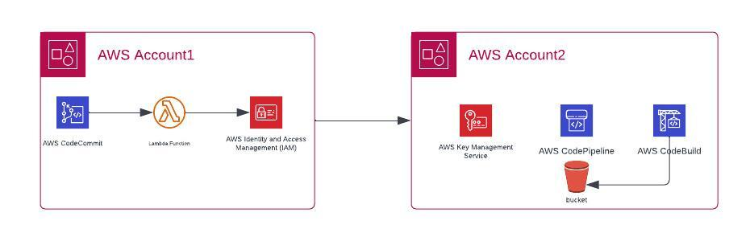

ACCOUNT – A: code commit account 954503069243

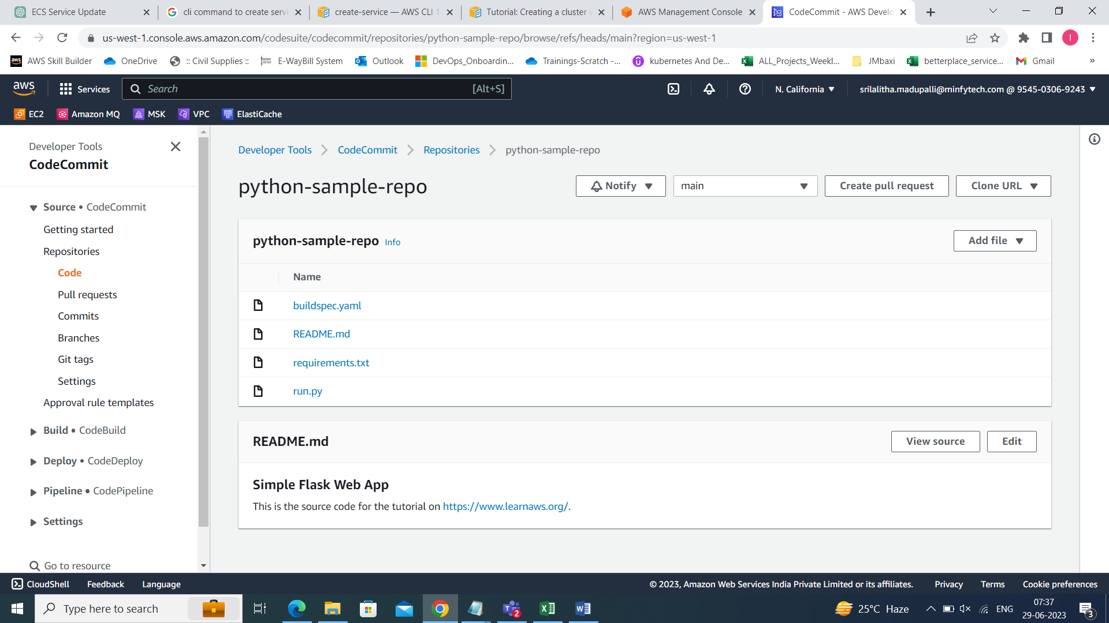

ACCOUNT – B: code pipeline account 240077723373

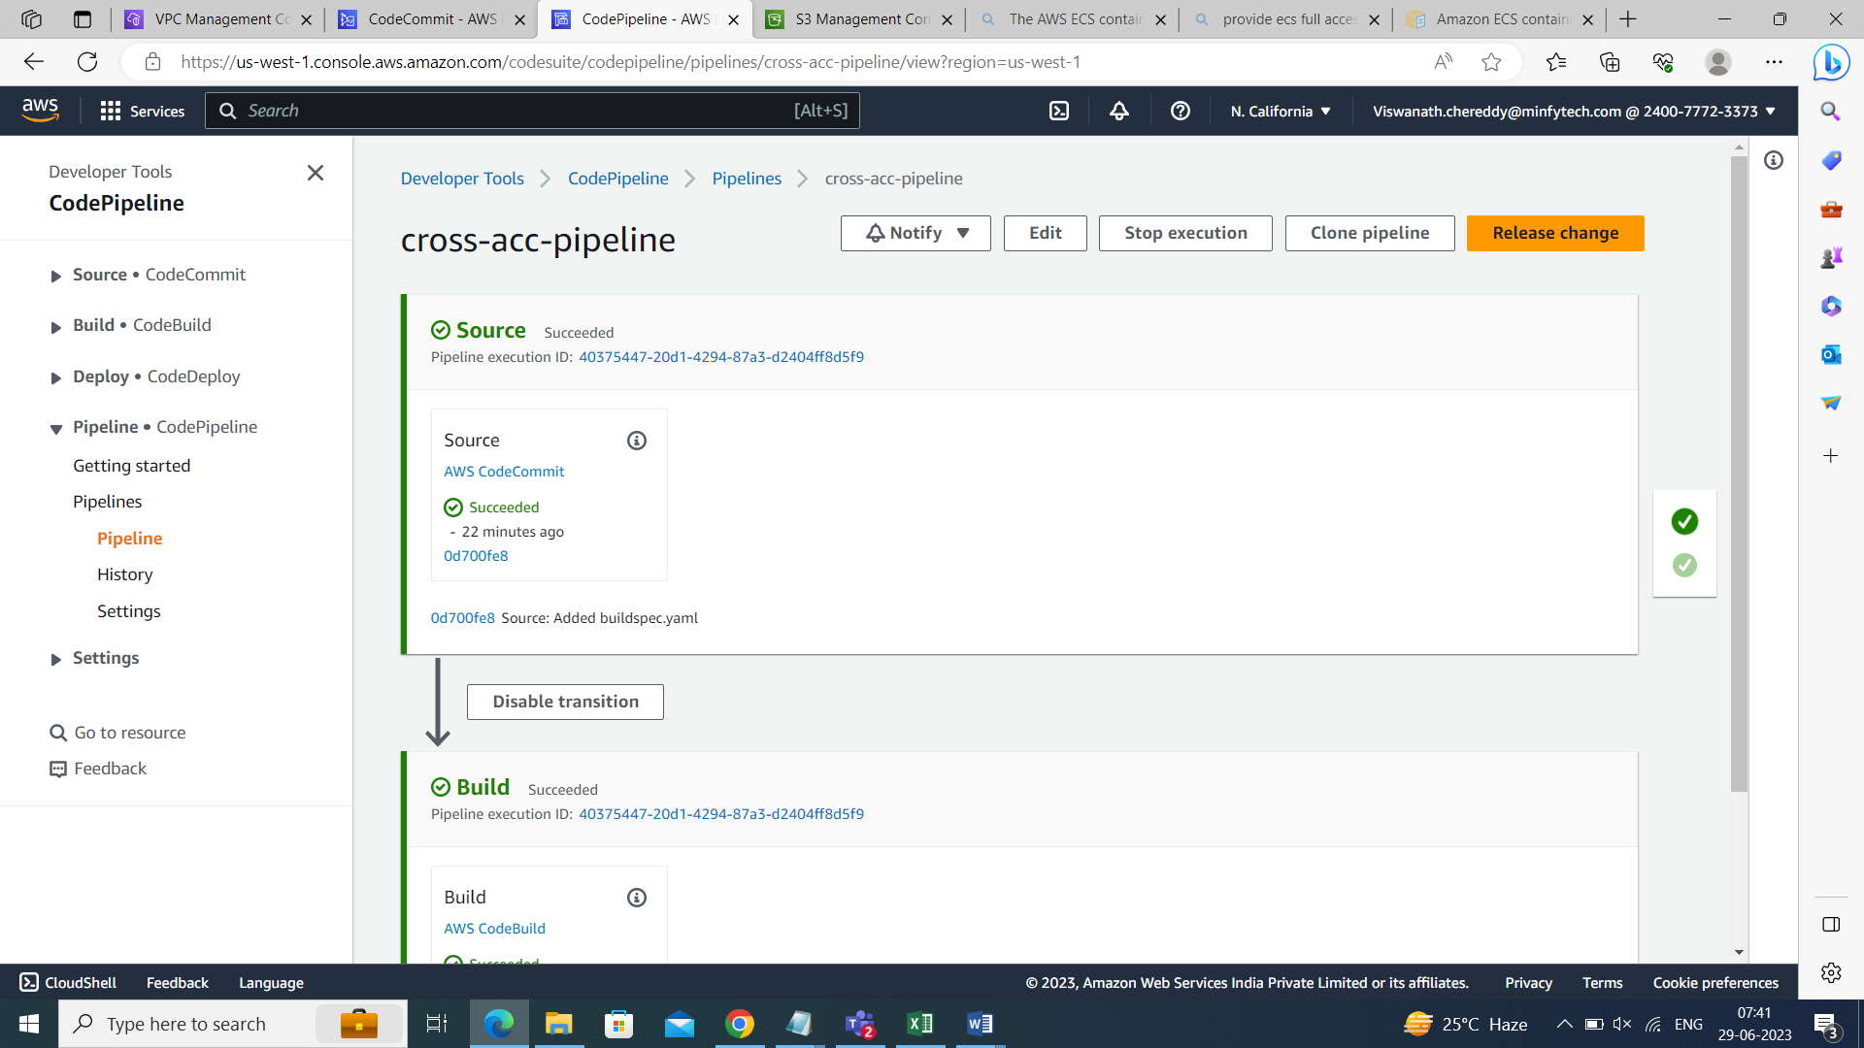

Activities to do in ACCOUNT-B:

Create a policy named: codecommit-account-policy

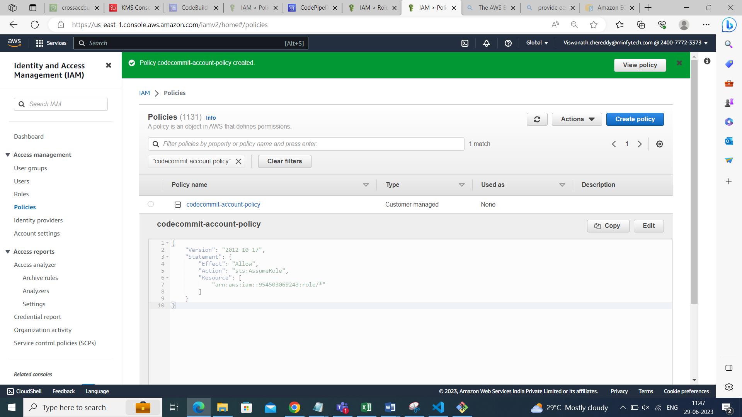

Attach this policy to codepipeline role

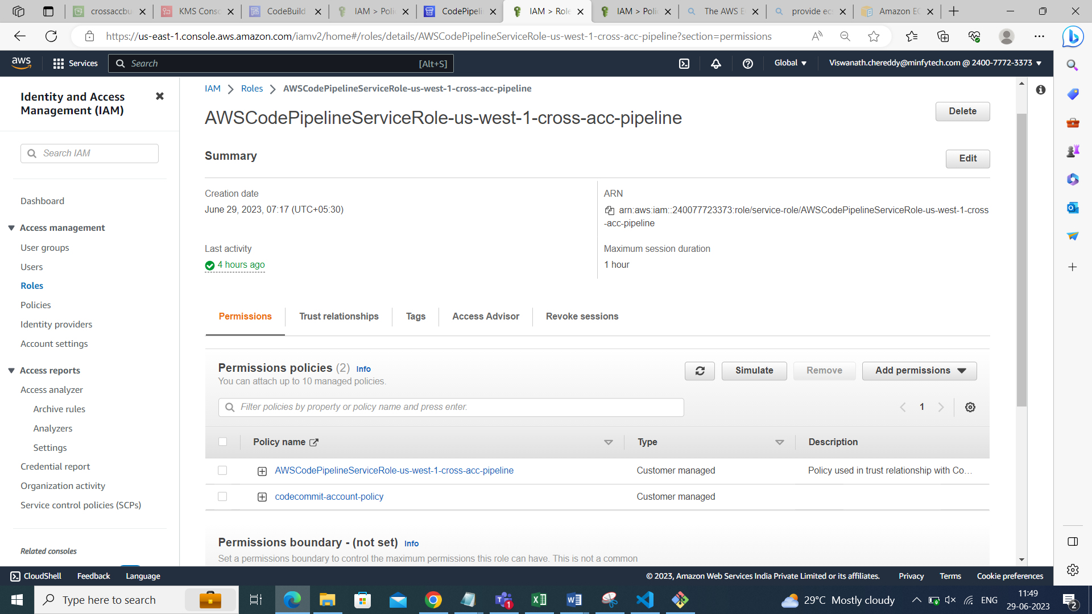

Create kmskey:

Name: crossaccount-key

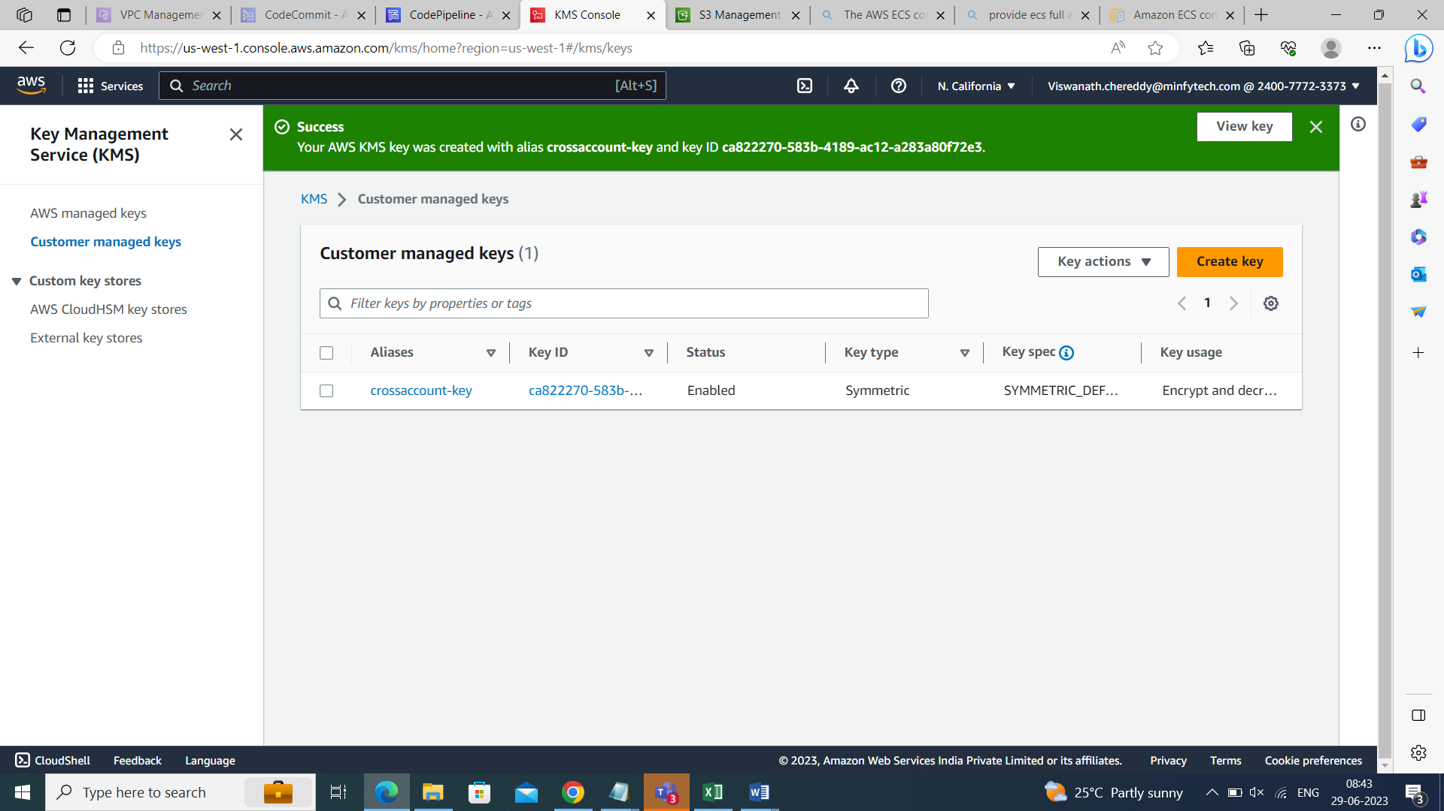

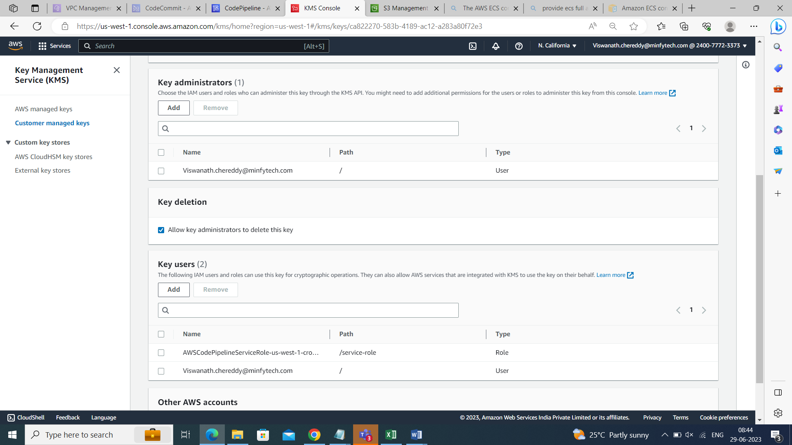

While creating the kms key add code commit accountID

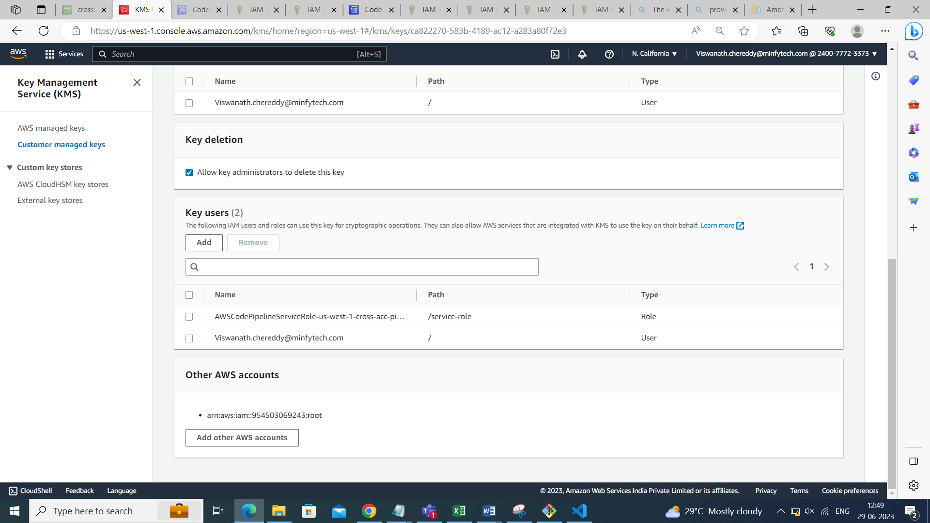

Copy the kms key arn:

arn:aws:kms:us-west-1:240077723373:key/ca822270-583b-4189-ac12-a283a80f72e3

Create s3 bucket:

Name: crossaccbuc

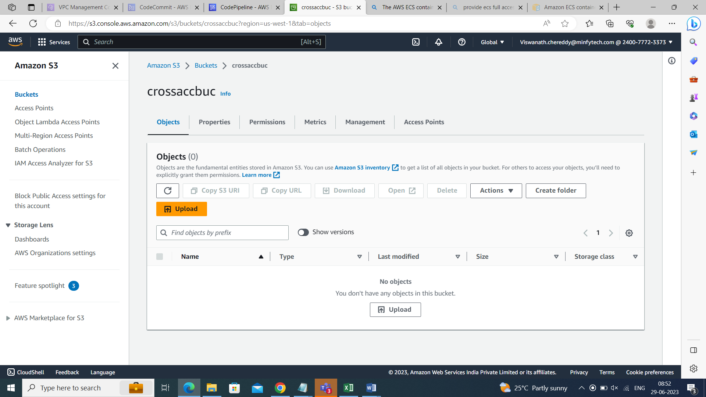

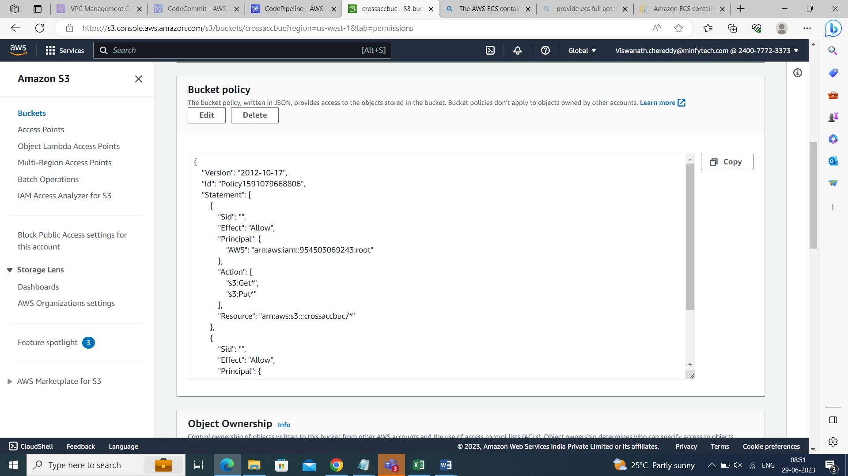

Create two plocies:

Policy-1: cross-account-lambda-pipelineaccess

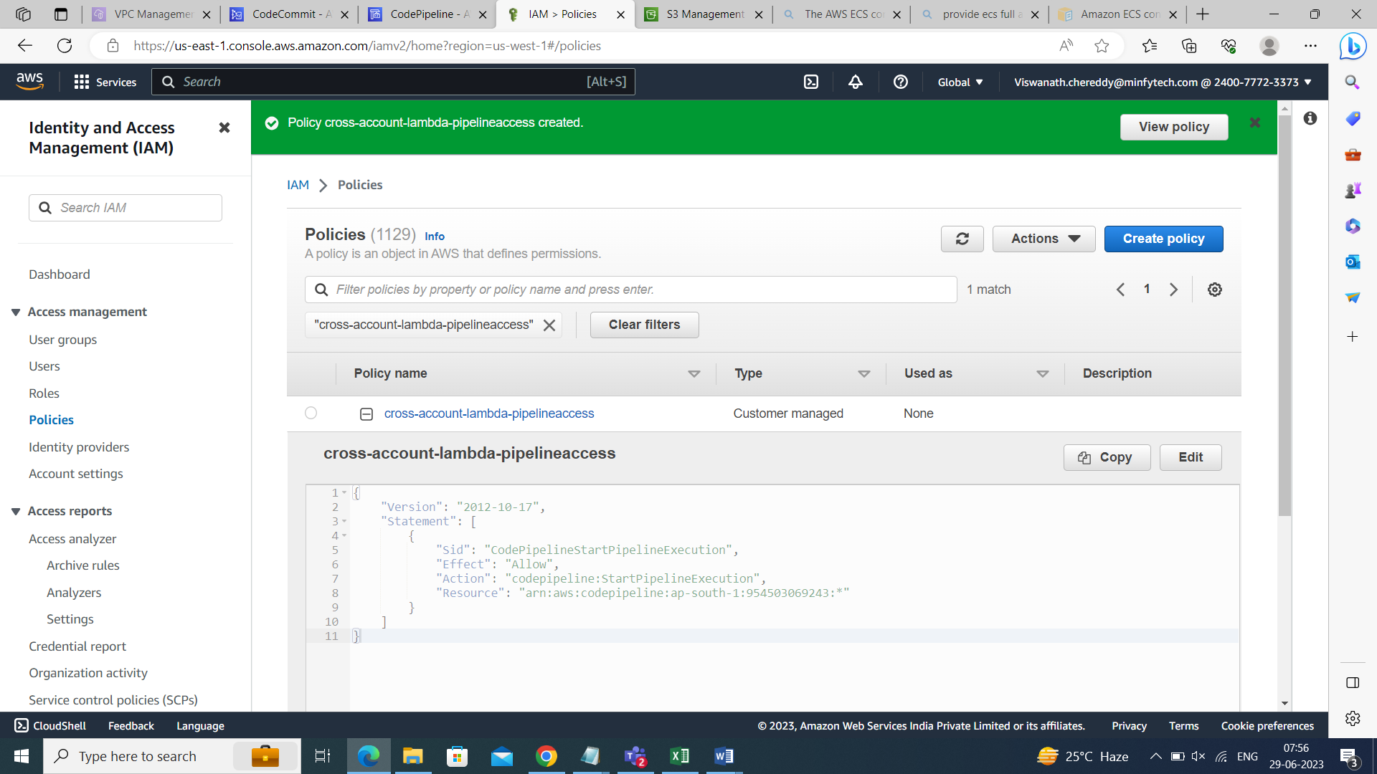

Policy-2: crossaccount-lambda

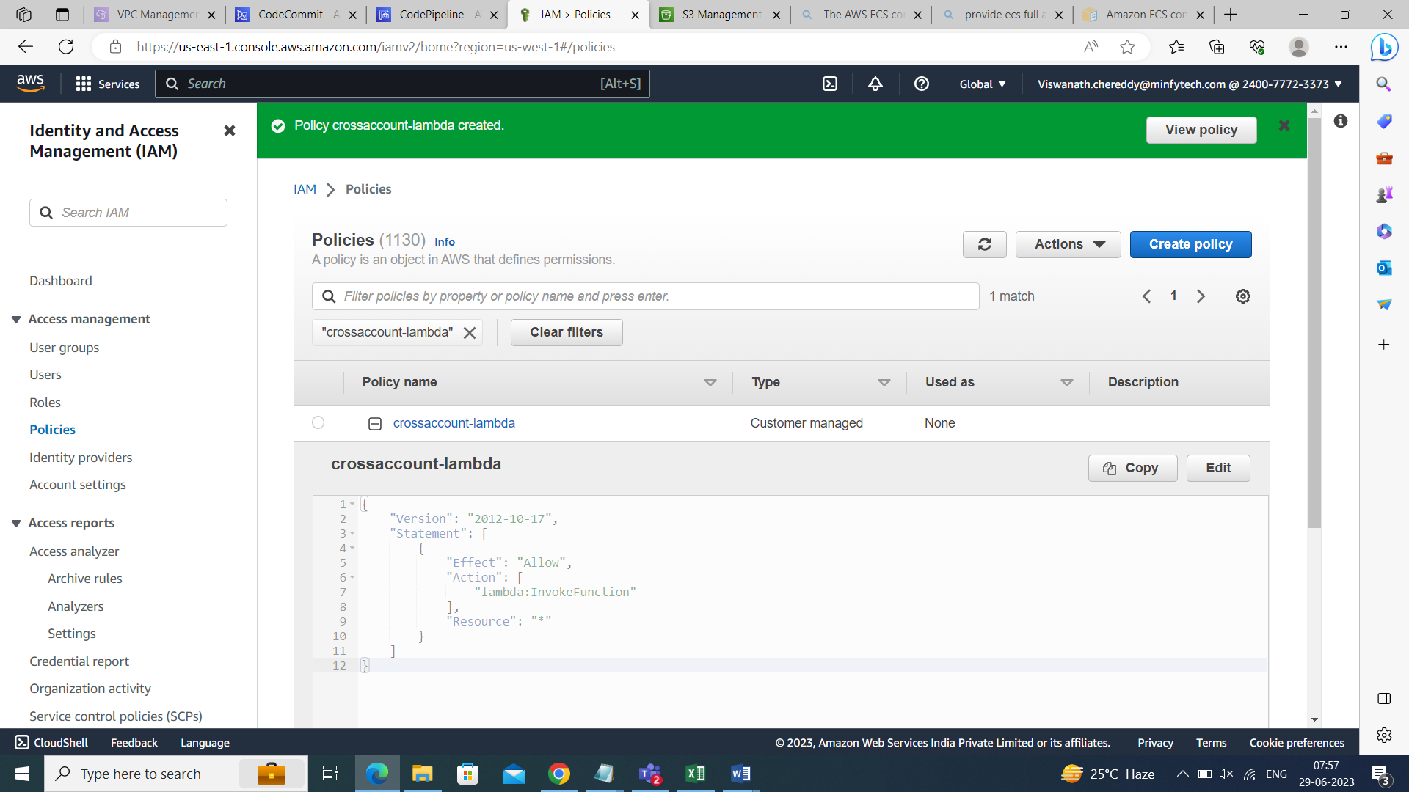

Create one role:

Attach these two policies in this role.

Rolename: cross-account-lambda-role

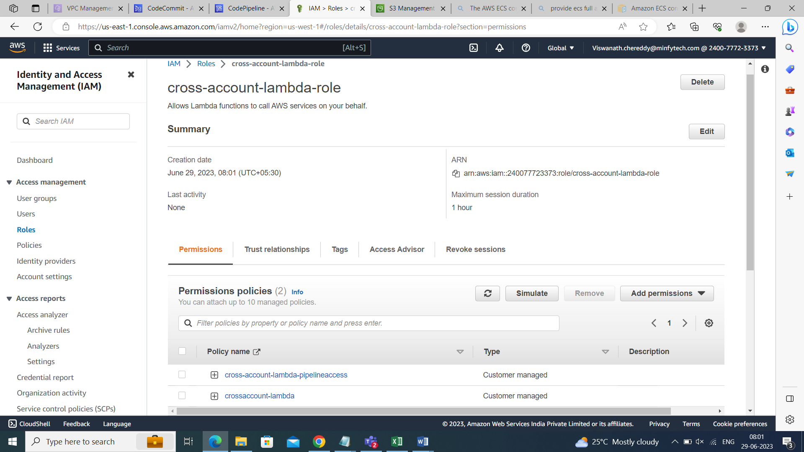

Change the trust relationship also

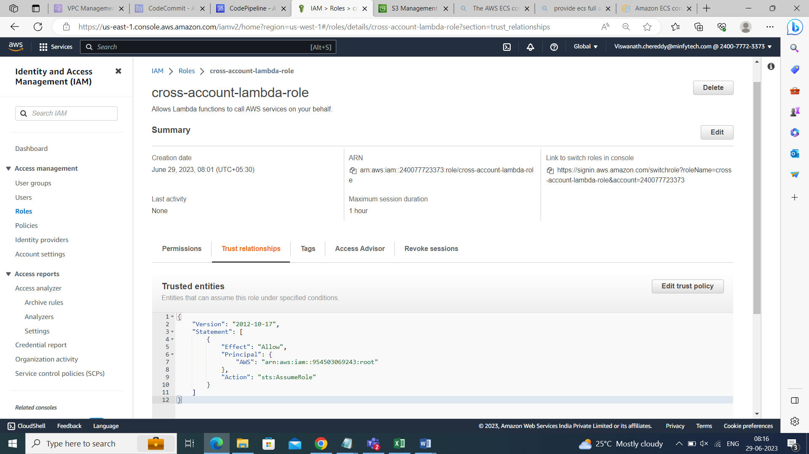

Copy the arn of that role : arn:aws:iam::240077723373:role/cross-account-lambda-role

>>>>>>>>>>>>>>>>>>>>>>>>>>>>>>>>>>>>>>>>>>>>>>>>>>>

Activities to do in ACCOUNT- A:

Create two policies:

Policy-1: cross-account-policy-lambda

To start the codepipeline execution “codepipeline:StartPipelineExecution”

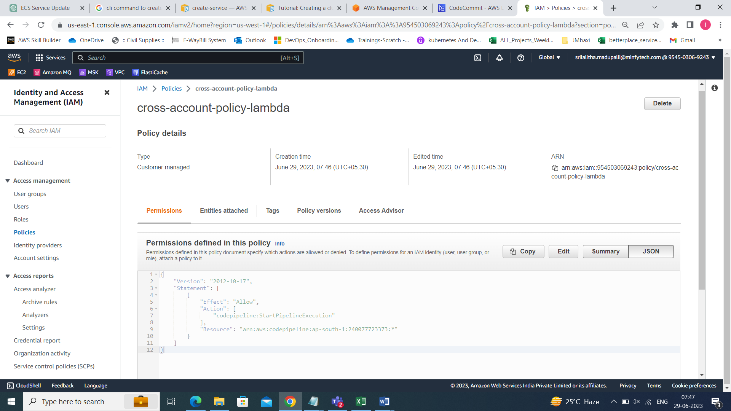

Policy-2: cross-acc-pipeline-role-policy //cross-account-lambda-policy

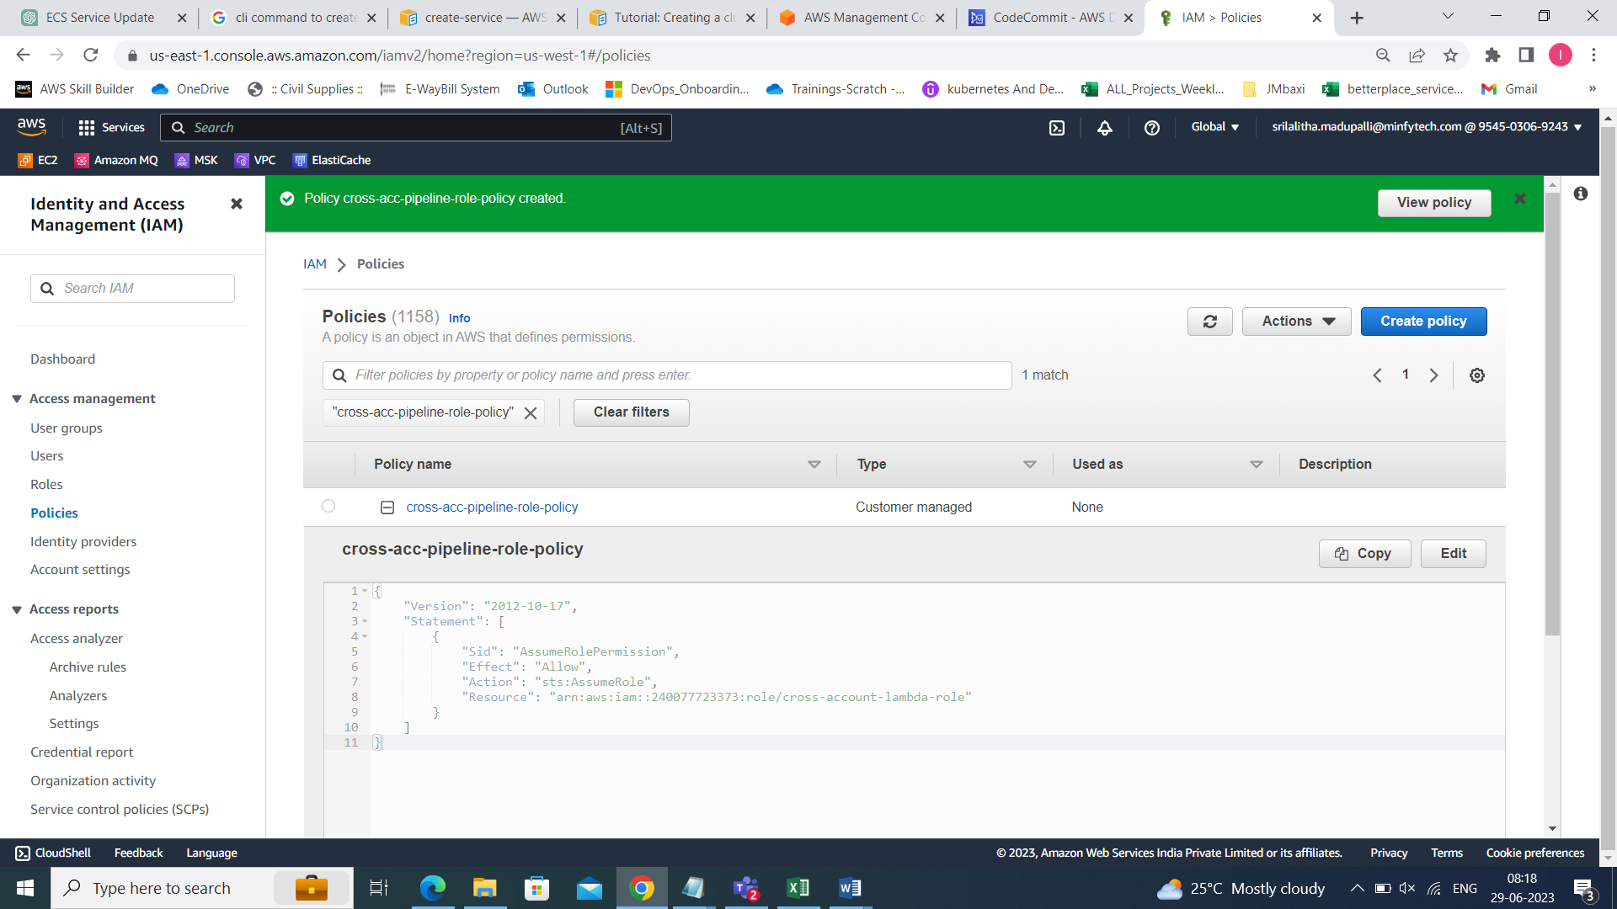

Create one lambda function:

Name: cross-account-function

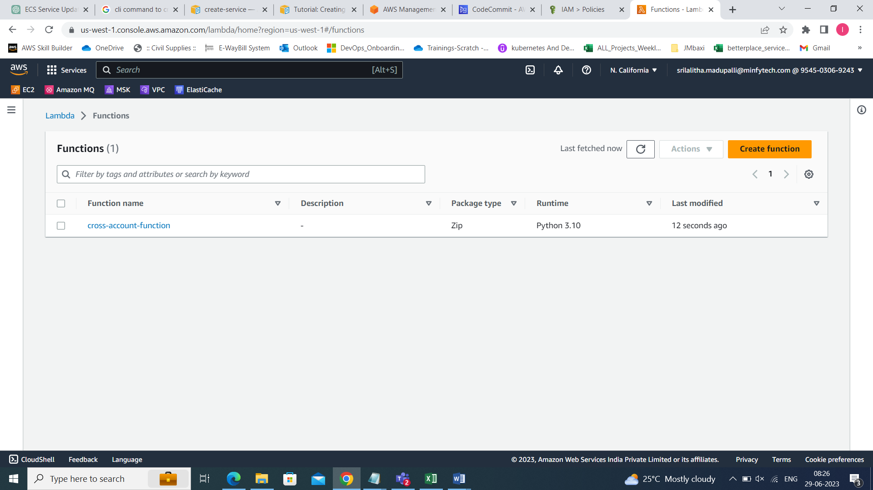

Go to lambda function role

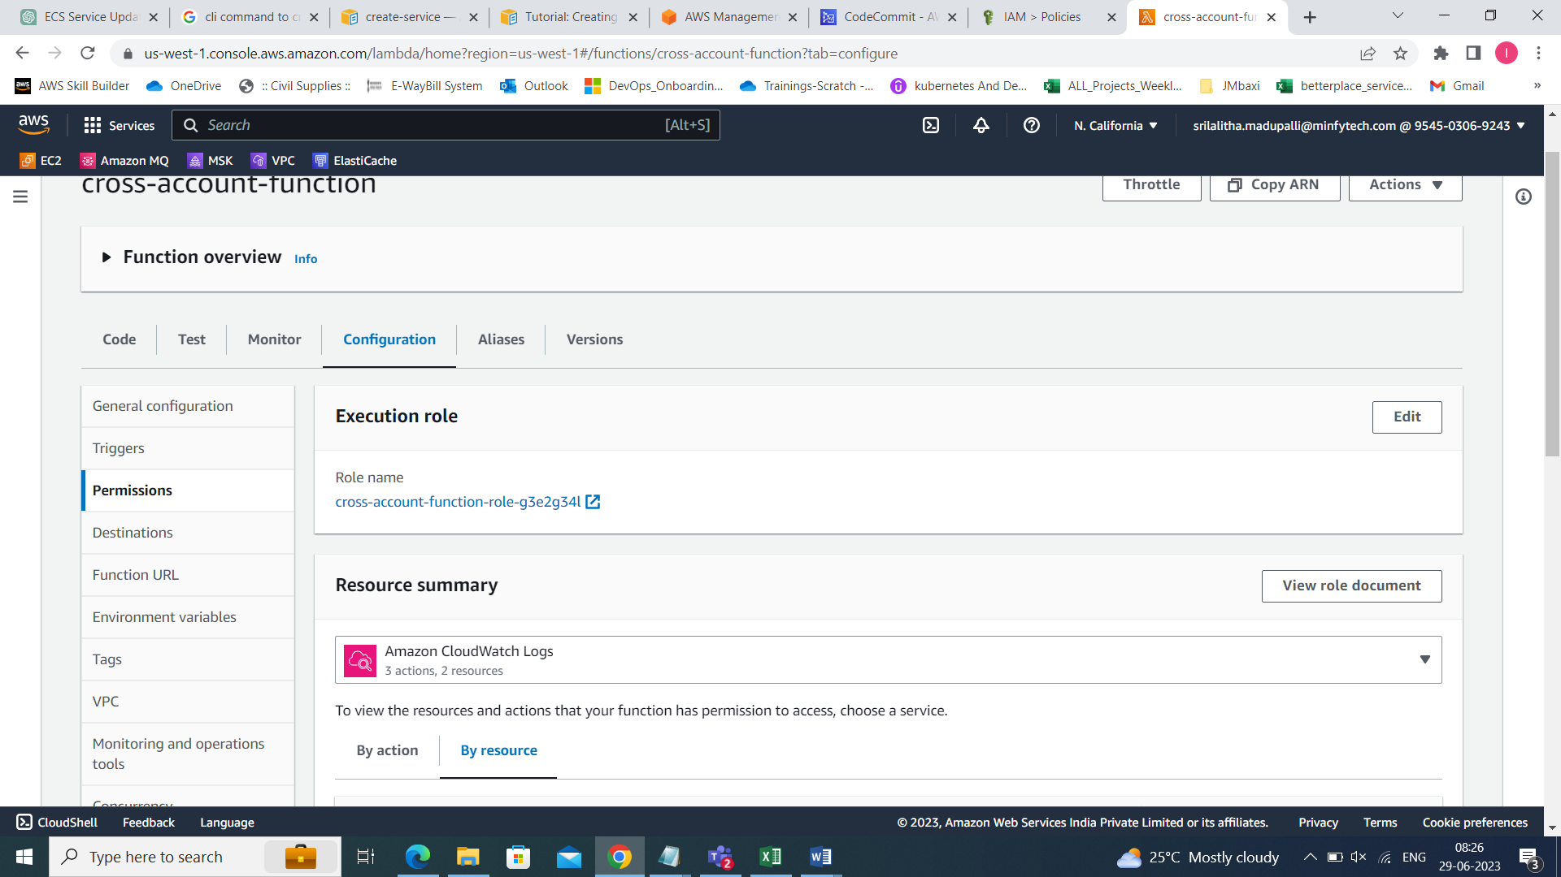

Attach the policies which we created in the above step

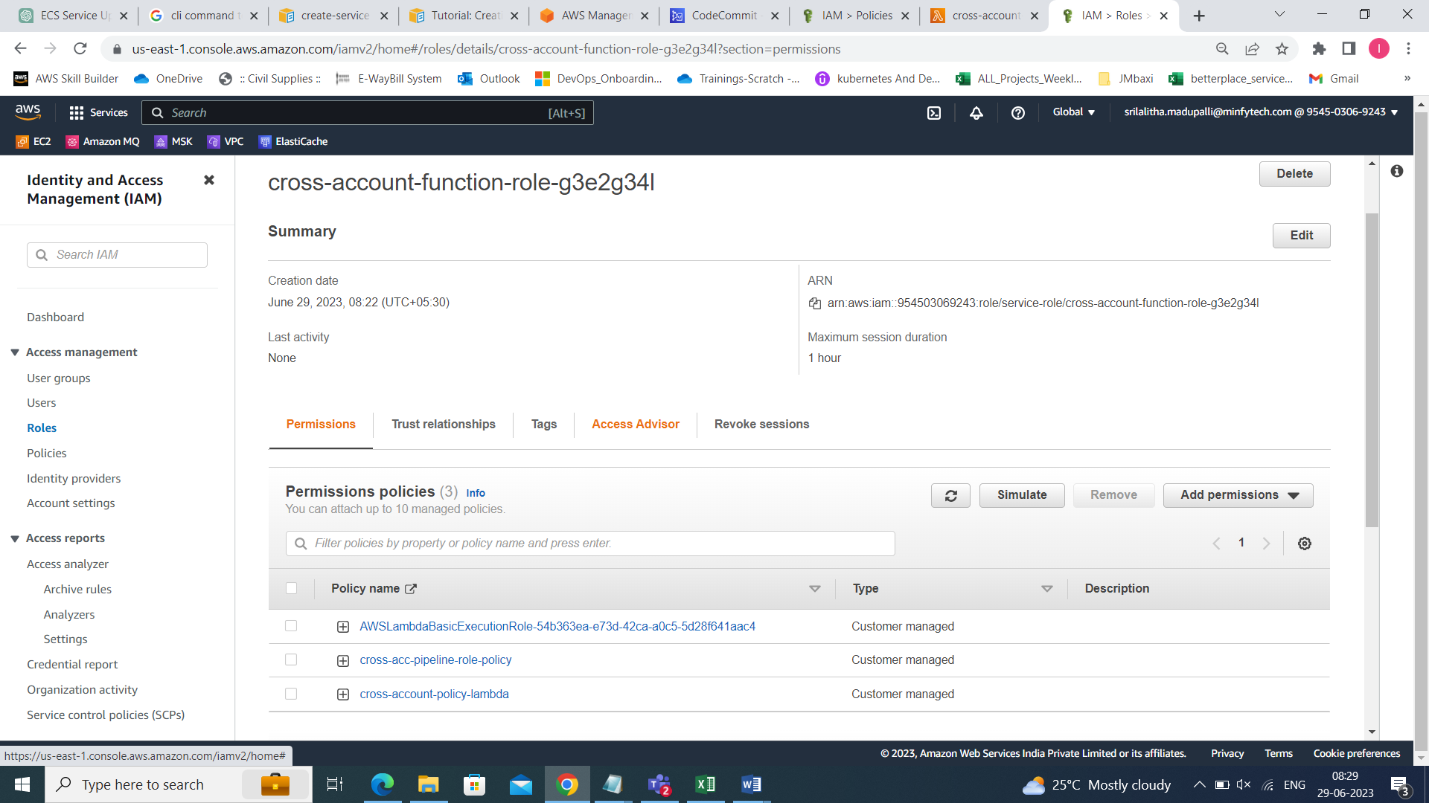

Below is the code to trigger the pipeline in account-B when the commit happens in account-A

In the code we have to give the pipeline name ex:“cross-acc-pipeline”

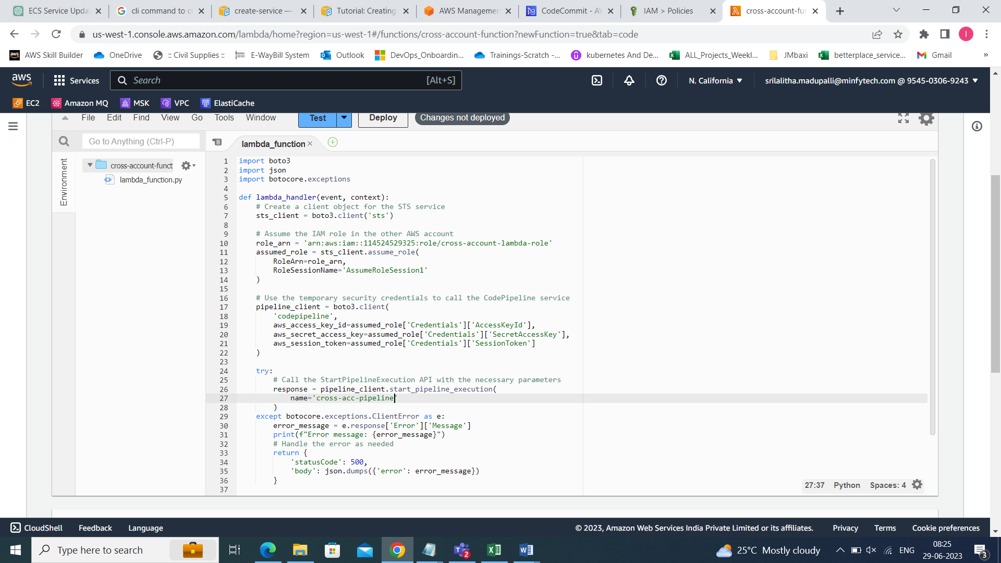

For this lambda function we have to add triggers also

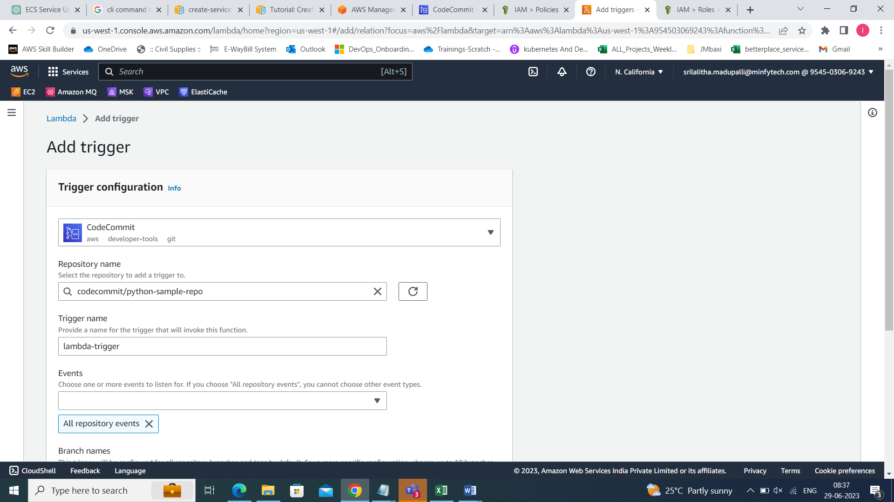

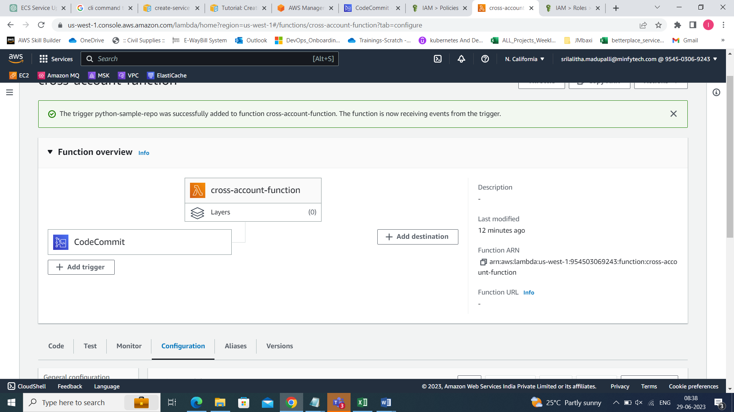

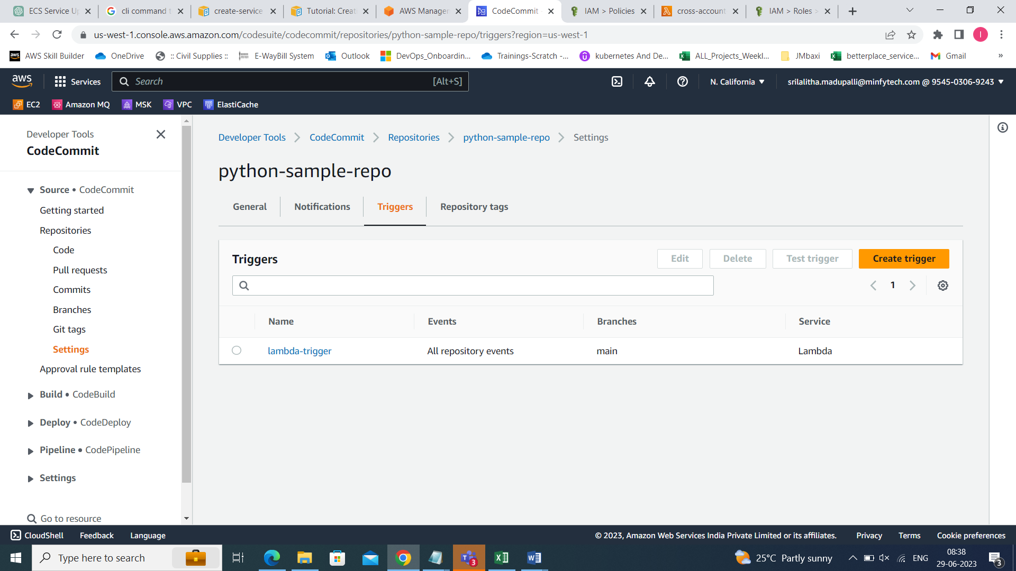

After all this again create one policy attaching the s3 bucket arn and kmskey arn which we are created in pipeline account

Name: cross-acc-access-policy

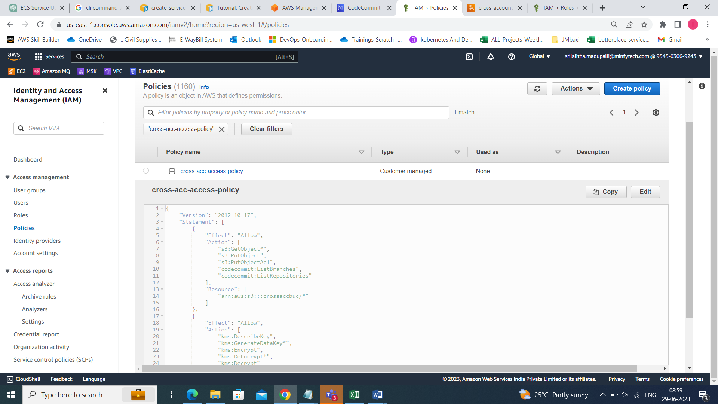

Create one role and attach this above policy and code commit full access

Name: cross-acc-access

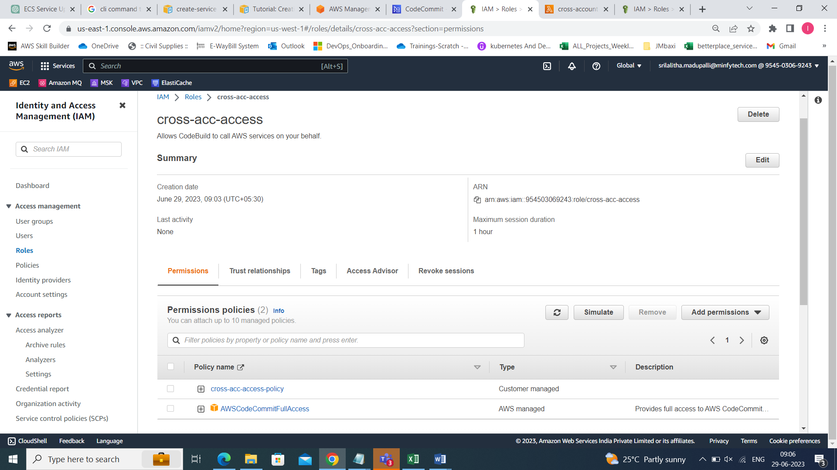

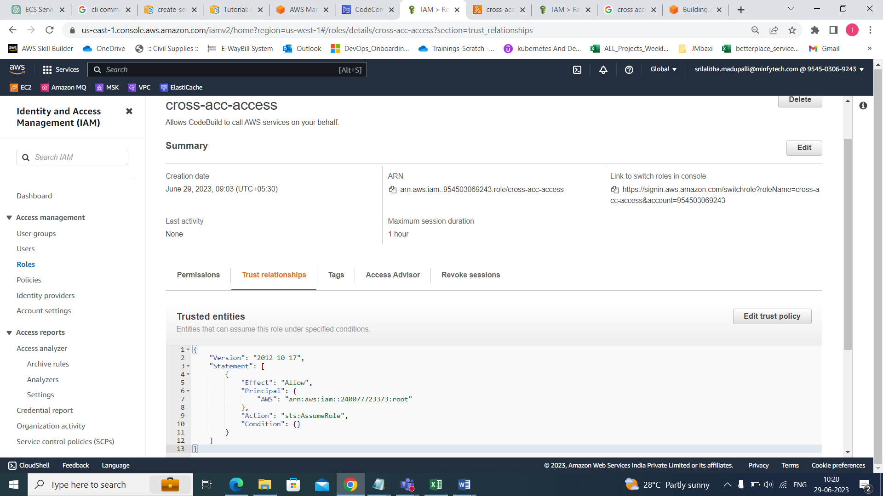

Now the setup is done, download the codepipeline from the codepipeline account in json formate by using the command

aws codepipeline get-pipeline --name pipeline-name > somethingname.json

aws codepipeline get-pipeline --name cross-acc-pipeline > cross-acc-pipeline.json

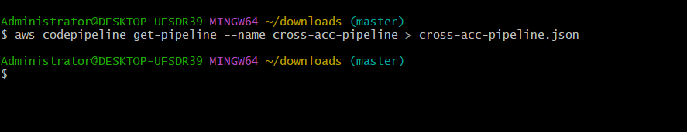

aws codepipeline update-pipeline --cli-input-json file:// cross-acc-pipeline.json

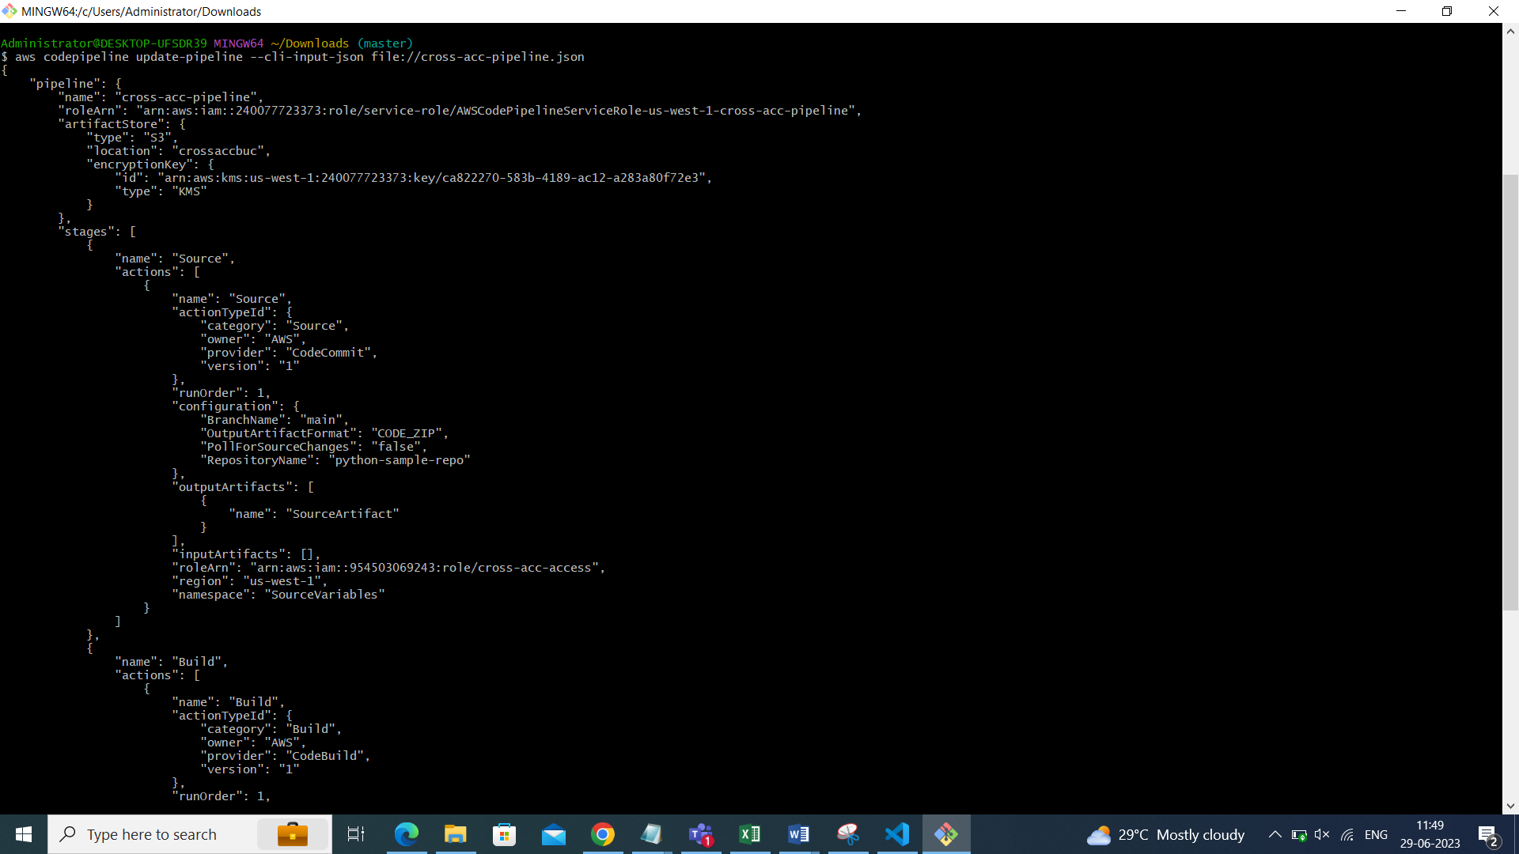

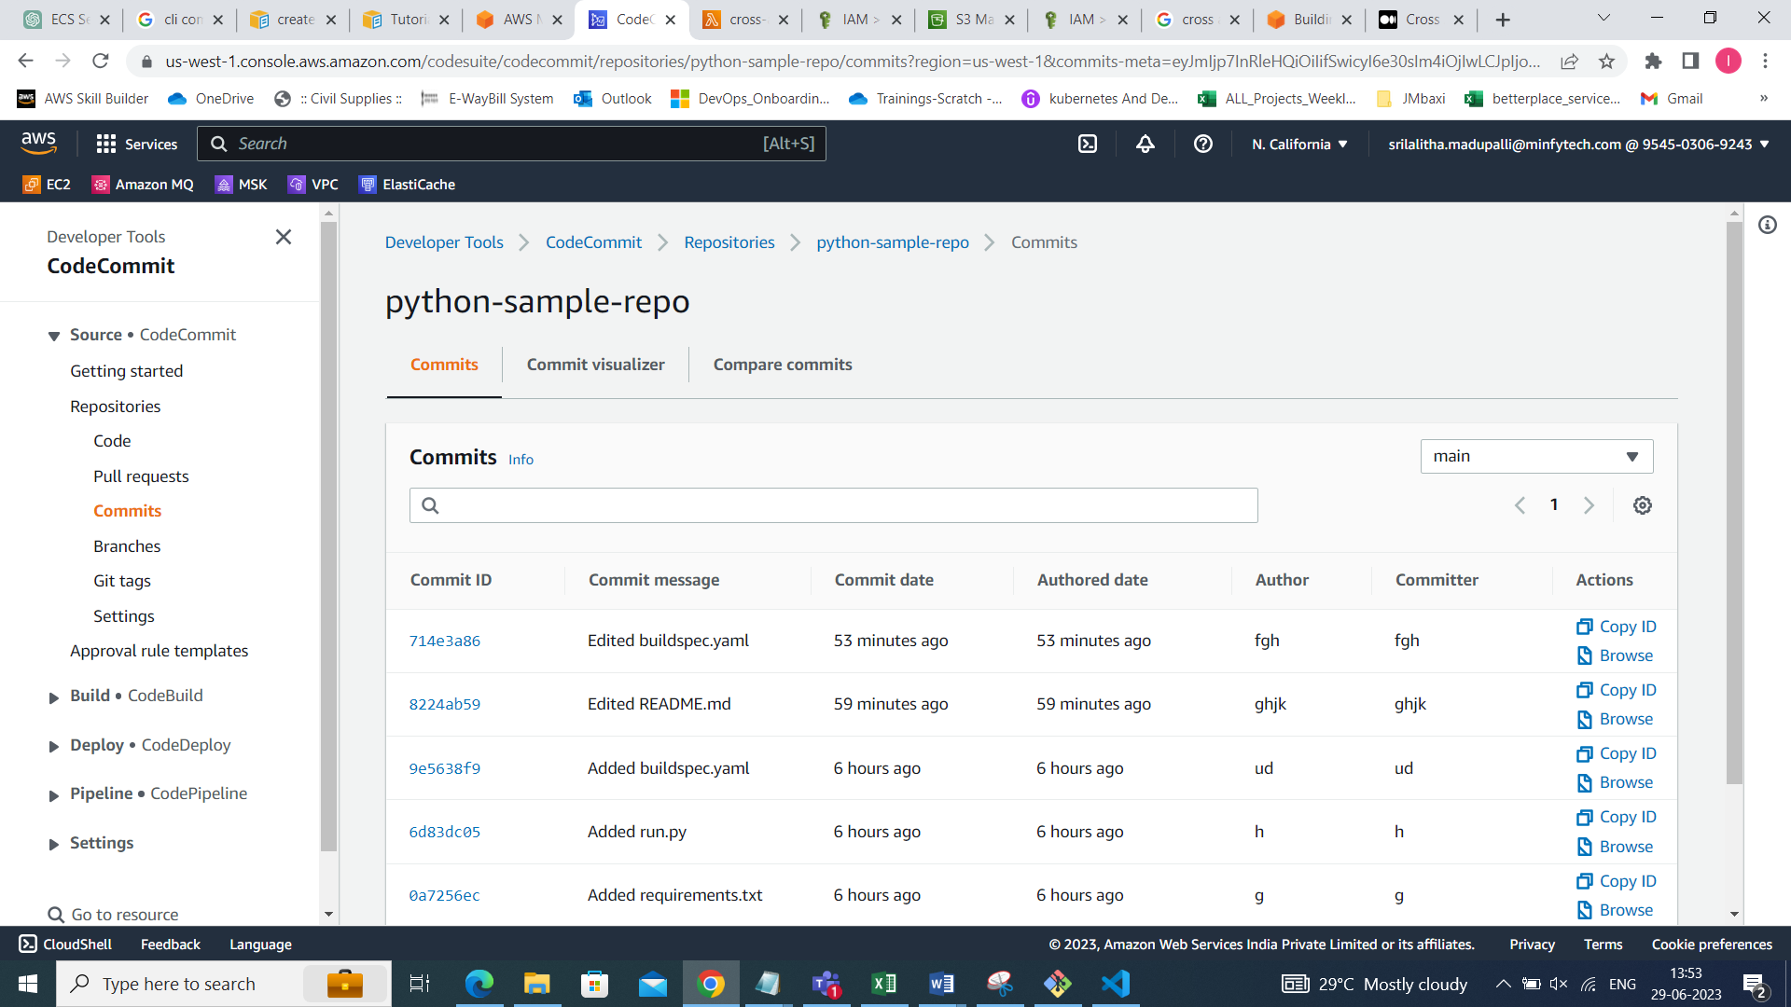

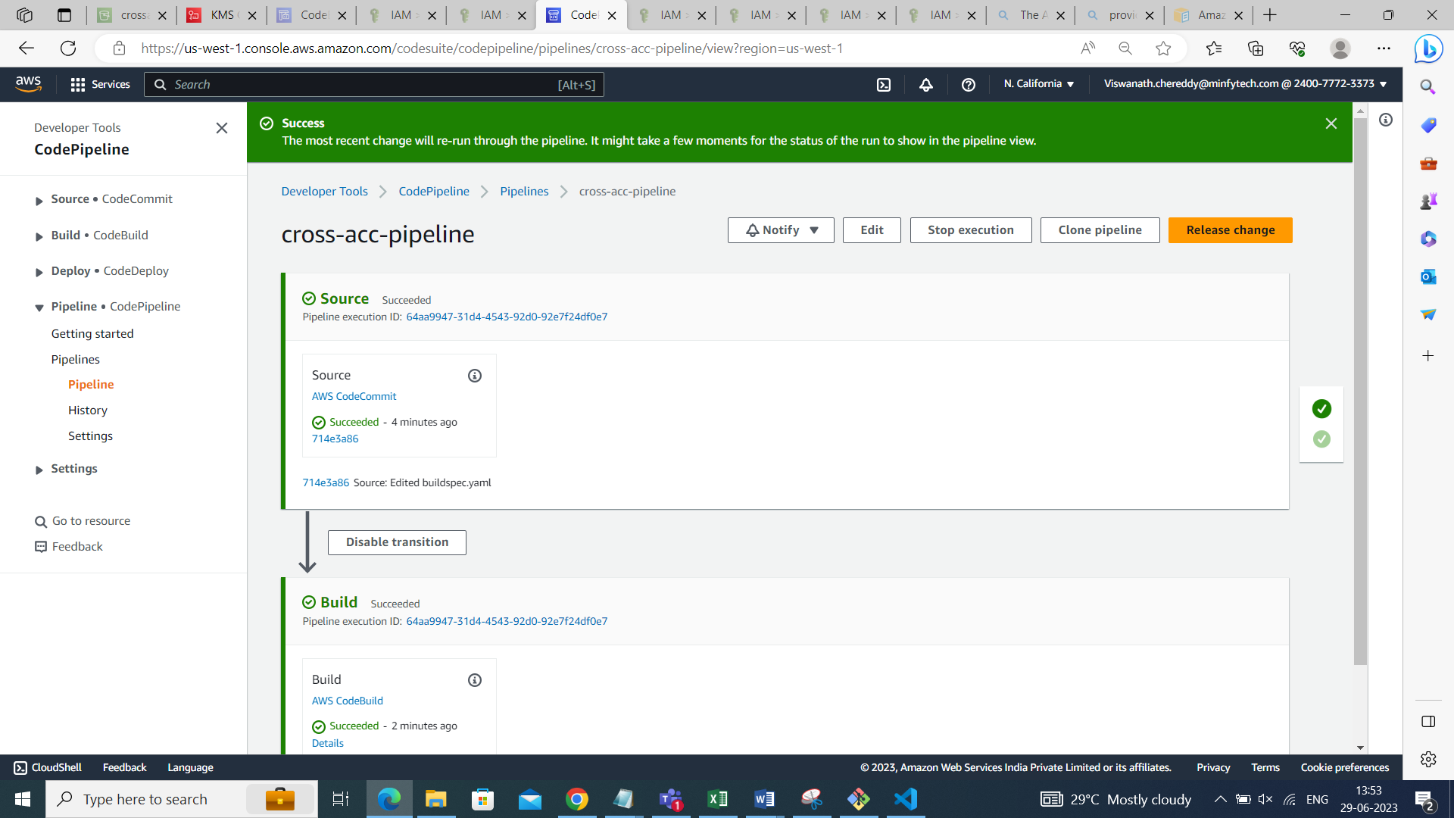

Ref: <https://prashant-48386.medium.com/cross-account-codepipeline-that-use-codecommit-from-another-aws-account-9d5ab4c892f6>